Chapter 7 programming

**7.21:** 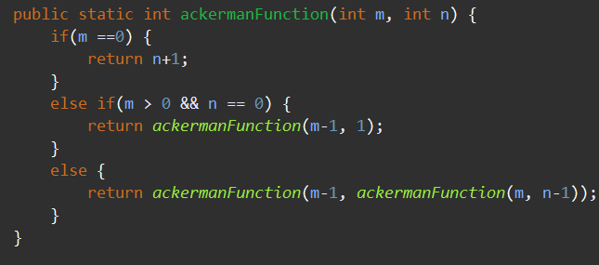

Did the base cases then the recursion

**7.23:**

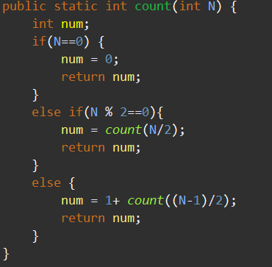

did the base cases and then the else for the recursion statement.

**7.36:**

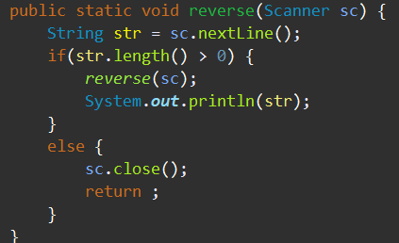

Made my base statements and then the recursion statements. Also print out the string.

**7.30: Extra credit**

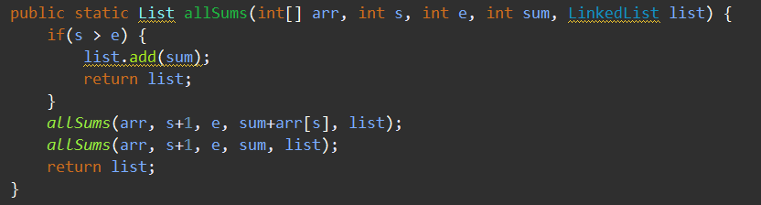

Make my base statement then two different recursion statements